Execute the application.

Note: Server should be run first followed by the client

**Test 1: Add a transaction to the block chain**

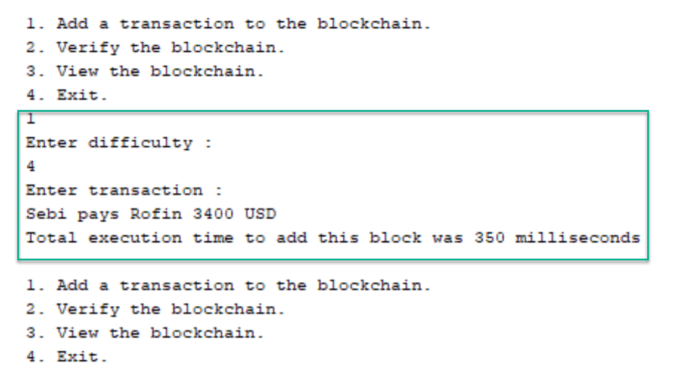

**Test 2: Verify the transaction**

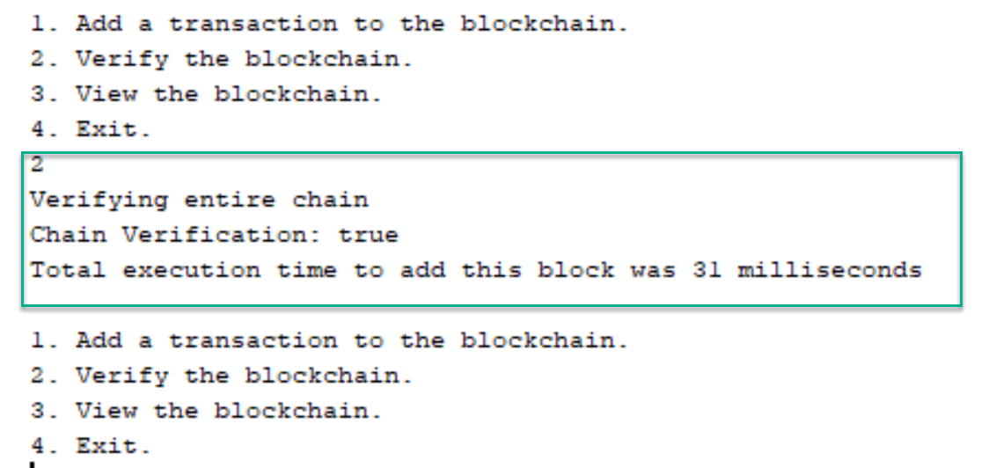

**Test 3: View the transactions of blockchain**

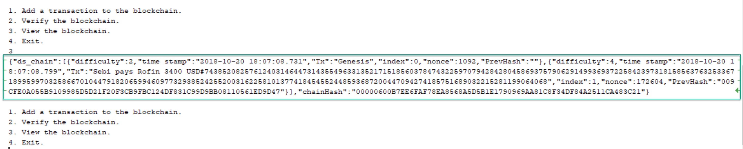

**Task 4: Exit**

